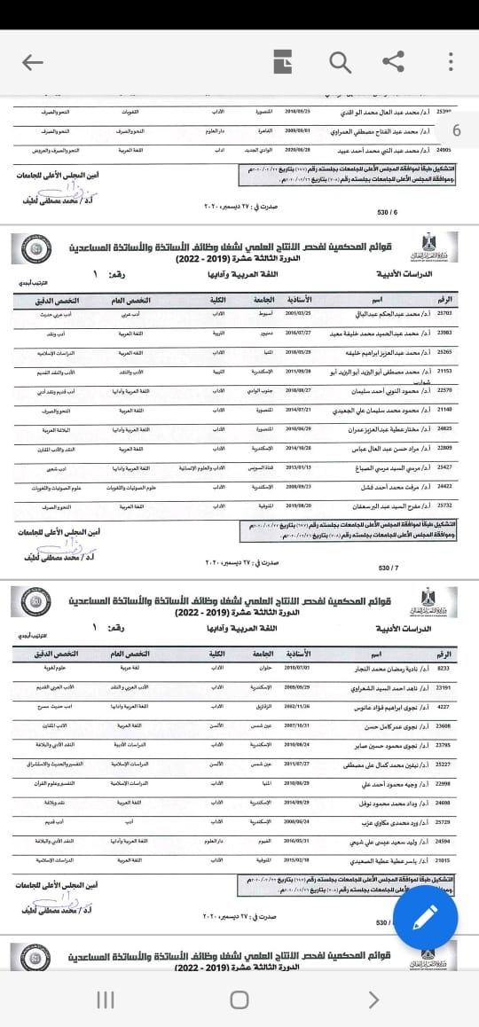

https://scu.eg/pages/promotion_committees

